Follow-Up Activities

Positivity and Engagement, Emiliya Zhivotovskaya, August 17, 2021

These are activities that you can do on your own, with a partner or with a small group of people. You could do some of these individually, some together, and then share with your partner or group how the activities are going, and support each other in building your own skills in positive psychology

Emiliya describes emotional Intelligence as being able to notice, name and navigate emotions within ourself and others.

Answer these fill in the blank questions.
- When I’m scared I want to ______?
- When I’m angry I want to _______?
- When I’m guilty I want to _______?
- When I’m sad I want to _______?
What types of words did you use to fill in those blanks? Did they have a common thread or theme?

Often people will in the blanks with words that represent either negative actions (yell, cry, hide) or actions that connect you with other people (talk to a friend, ask someone for advice). These types of emotions come from evolution, from our need for either fight/flight/freeze or to tend and befriend.

Answer these fill in the blank questions.
- When I’m grateful I want to ______?
- When I’m curious I want to _______?
- When I’m in love I want to _______?
- When I’m sad I want to _______?
What types of words did you use to fill in those blanks? Did they have a common thread or theme?

Often people will in the blanks with words that represent positive actions (hug someone, ask question). These types of emotions come from evolution as well, from our need to broaden and build, to connect with other people.

To learn more about broaden and build you can watch Positive Psychologist and Researcher Barbara Fredrickson’s video - https://www.youtube.com/watch?v=Z7dFDHzV36g

Activity

Draw the ginger person shape below 6 times. Then color in what the emotions listed below are like for you, inside your body. Use one ginger person for each emotion and try using colors, shapes, or different size and thickness of lines. Create something that expresses what each emotion feels like to you. Really connect with how your body feels when you experience the particular emotion.
- Angry
- Worried
- Sad
- Excited
- Grateful
- Love

Next, in small groups or pairs, share your drawings. Then as a whole group or individual reflection answer these questions:
What was it loke to compare and contrast drawings and how you feel emotions with someone else?
Did hearing your someone else share their feelings give you any new insight into your own feelings?

This activity is individual and will play out differently for each person. However, generally after this activity people find that negative emotions are felt in a more centrally located or smaller area of the body. Positive emotions are often more spread out throughout the body or even outside of your body.

Havening
During the presentation Emiliya described Havening, and she demonstrated how to use havening. You can also learn more about Havening from the website below.

www.haveningtechnique.org

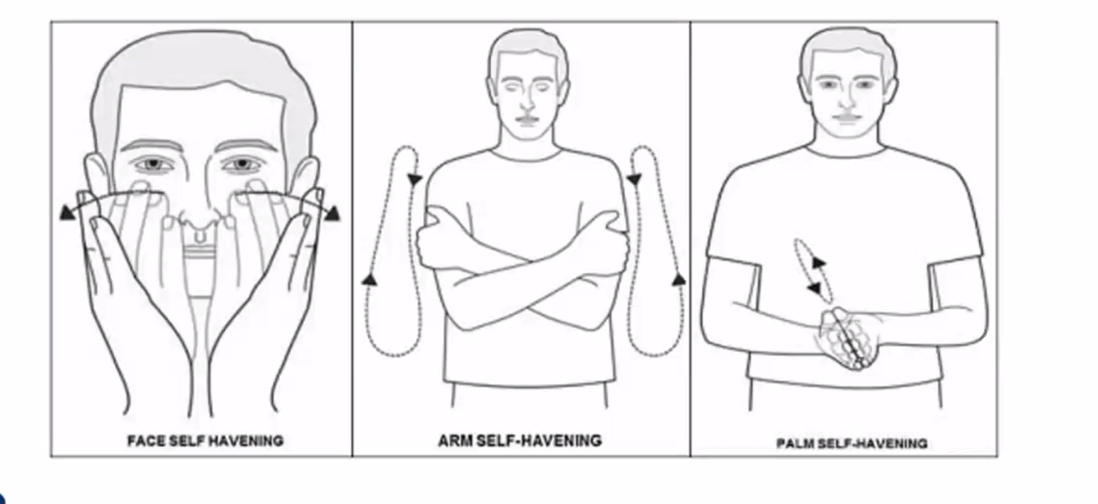
For the arm self-havening technique, you want to move your hands from your shoulders to your elbows, then take your hands off of your elbows and place them on your shoulders and move down again. So, you are always moving your hands down, not moving them down and up.

For the palm self-havening technique, you are moving one hand from the wrist to the fingertips of the opposite hand. Your hands can be aligned like the image, or your hands can look for like an a T as you move from wrist to finger tips.

