School Preparedness Program
We all face risks and vulnerabilities. Not every risk can be eliminated. While some risks can be mitigated, disasters and crises will happen. Establishing a clear crisis management plan with identified leadership authority positions an organization to manage a crisis effectively. Identifying what needs to be monitored with predetermined triggers for action empowers people to act immediately. Having predetermined roles, responsibilities, and actions, positions leadership in a position to implement actions consistent with the strategy and school mission. The middle of a crisis is not the time to start trying to figure who the players are and what the game plan is.
Mapping the right route to any destination requires some mission-critical facts: Starting point. Distance. Best and alternate routes. Without this information, the map is unlikely to guide you or your organization to the right outcome in an efficient manner.
Where Do You Start? – The School Preparedness Program
Firestorm has managed numerous crises in public and private companies, schools, and government organizations. The Firestorm senior leadership lessons learned are based upon decades of crisis and consequence management experience in managing crisis outcomes successfully.
The Firestorm will empower you to be able make the decisions you need to make before, during, and after a crisis. The Firestorm Predict.Plan.Perform.® process for crisis and consequence management optimizes outcomes and restores your management control.
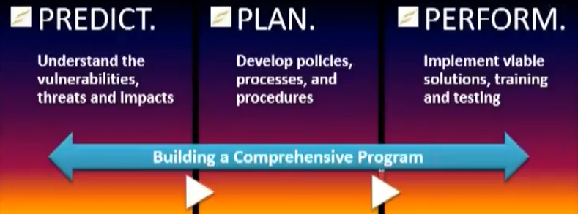

The school preparedness program provides you an opportunity to discover and plan for what you need to do in a crisis, interact with first responders, other organizations, businesses, understand the impacts of disasters and crises, develop your business continuity plans, learn about emerging threats and risks, participate in a crisis management training, simulation exercise, and receive answers to your questions.
“What should we do now?” “What should we say?”
How you answer the question “What should we do now?” can have far reaching implications for your organization. Often, these questions are complex and require far more than insurance claims or legal responses. Your organization will need services that focus on the human, operational, reputational and financial impacts of such a disaster or crisis. There may be life and safety issues. Security may be needed to secure the premises. Communication will be required with all stakeholders, and depending on the extent of the crisis, the press may surface, making the need for media training critical. There may be supply chain and provider disruption, creating contractual liability exposures. There may be regulatory impacts.
Preparedness and Resiliency are key brand attributes for every organization. Crises come as surprises. Control of events and message are lost. Impacts accelerate. Public scrutiny intensifies.
Are you ready? How do you know? Are you sure?
The dynamics below work aggressively against traditional empirical management decision processes. Decisions must be made quickly with limited and often incorrect information. Crises have a short duration, but have consequences that can determine the viability of a business or organization for years to come. A crisis is not business as usual. A crisis is business as unusual. If you are explaining, you are losing.
Most school leaders are trained to make decisions based upon information, data, and policy. In a crisis:
- Information is generally wrong | - Leadership is involved and engaged personally
- Data is not available | - Impacts are disproportional
- Policies do not exist | - Events are escalating
- Command & Control is lost | - Speed is quality or even survival
- Brand & reputation are under attack | - You are the center of media focus
Crises have impacts – for good and bad. Every crisis starts with a combination of opportunity and danger. Where the risk/crisis conundrum balances depends upon your initial critical decisions, your crisis communications, your monitoring of events, and your adjustments made to strategy and actions as events develop. Your organization’s reputation, brand, legacy, and profitability hang in the balance in a crisis. Crises are personal. Every crisis is a human crisis. It is your organization. It is your people. It is your brand. It is your reputation. Doing the wrong thing or doing nothing can create a point of no return.
The Firestorm School Preparedness Program – One Step Ahead
Over 70,000 disasters occur annually in the U.S. alone. While they can’t be scheduled, they can be predicted and planned for. The consequences can be managed and mitigated. An organization may have addressed many risk factors and have some plans in place. Budget restrictions and available resources can limit the ability to address all exposures and needs.
Firestorm leadership supports your management and organization before, during, and after a crisis. Firestorm empowers people to manage risk and crises. Firestorm expertise is crisis management, critical decision support, crisis communications, crisis public relations, and consequence management.

